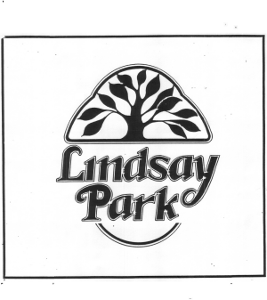

LINDSAY PARK HOMEOWNERS ASSOCIATION

ARCHITECTURAL REVIEW BOARD

APPLICATION FOR EXTERIOR ADDITIONS AND ALTERATIONS

NAME |  | DATE

ADDRESS |  | TELEPHONE

PROPOSAL: (NOTE – INCLUDE DRAWINGS, PHOTOGRAPHS, SITE PLANS, COLOR SAMPLES, OR MATERIAL LISTS AS APPROPRIATE

EXPECTED START DATE |  | EXPECTED COMPLETION DATE

HOMEOWNER'S SIGNATURE

THIS APPLICATION SHALL BE DEEMED TO BE APPROVED AUTOMATICALLY IF THE ARCHITECTURAL REVIEW BOARD HAS FAILED TO ACT ON IT WITHIN THIRTY (30) DAYS.
- - - - - - - - - - - - - - - - - - - - - - - - - - - - - - - - - - -

THE ARCHITECTURAL REVIEW BOARD HAS |  | APPROVED; |  | NOT APPROVED
THIS APPLICATION WITH THE FOLLOWING COMMENTS:

DATE |  | SIGNATURE CHAIRMAN, ARCHITECTURAL  REVIEW BOARD

